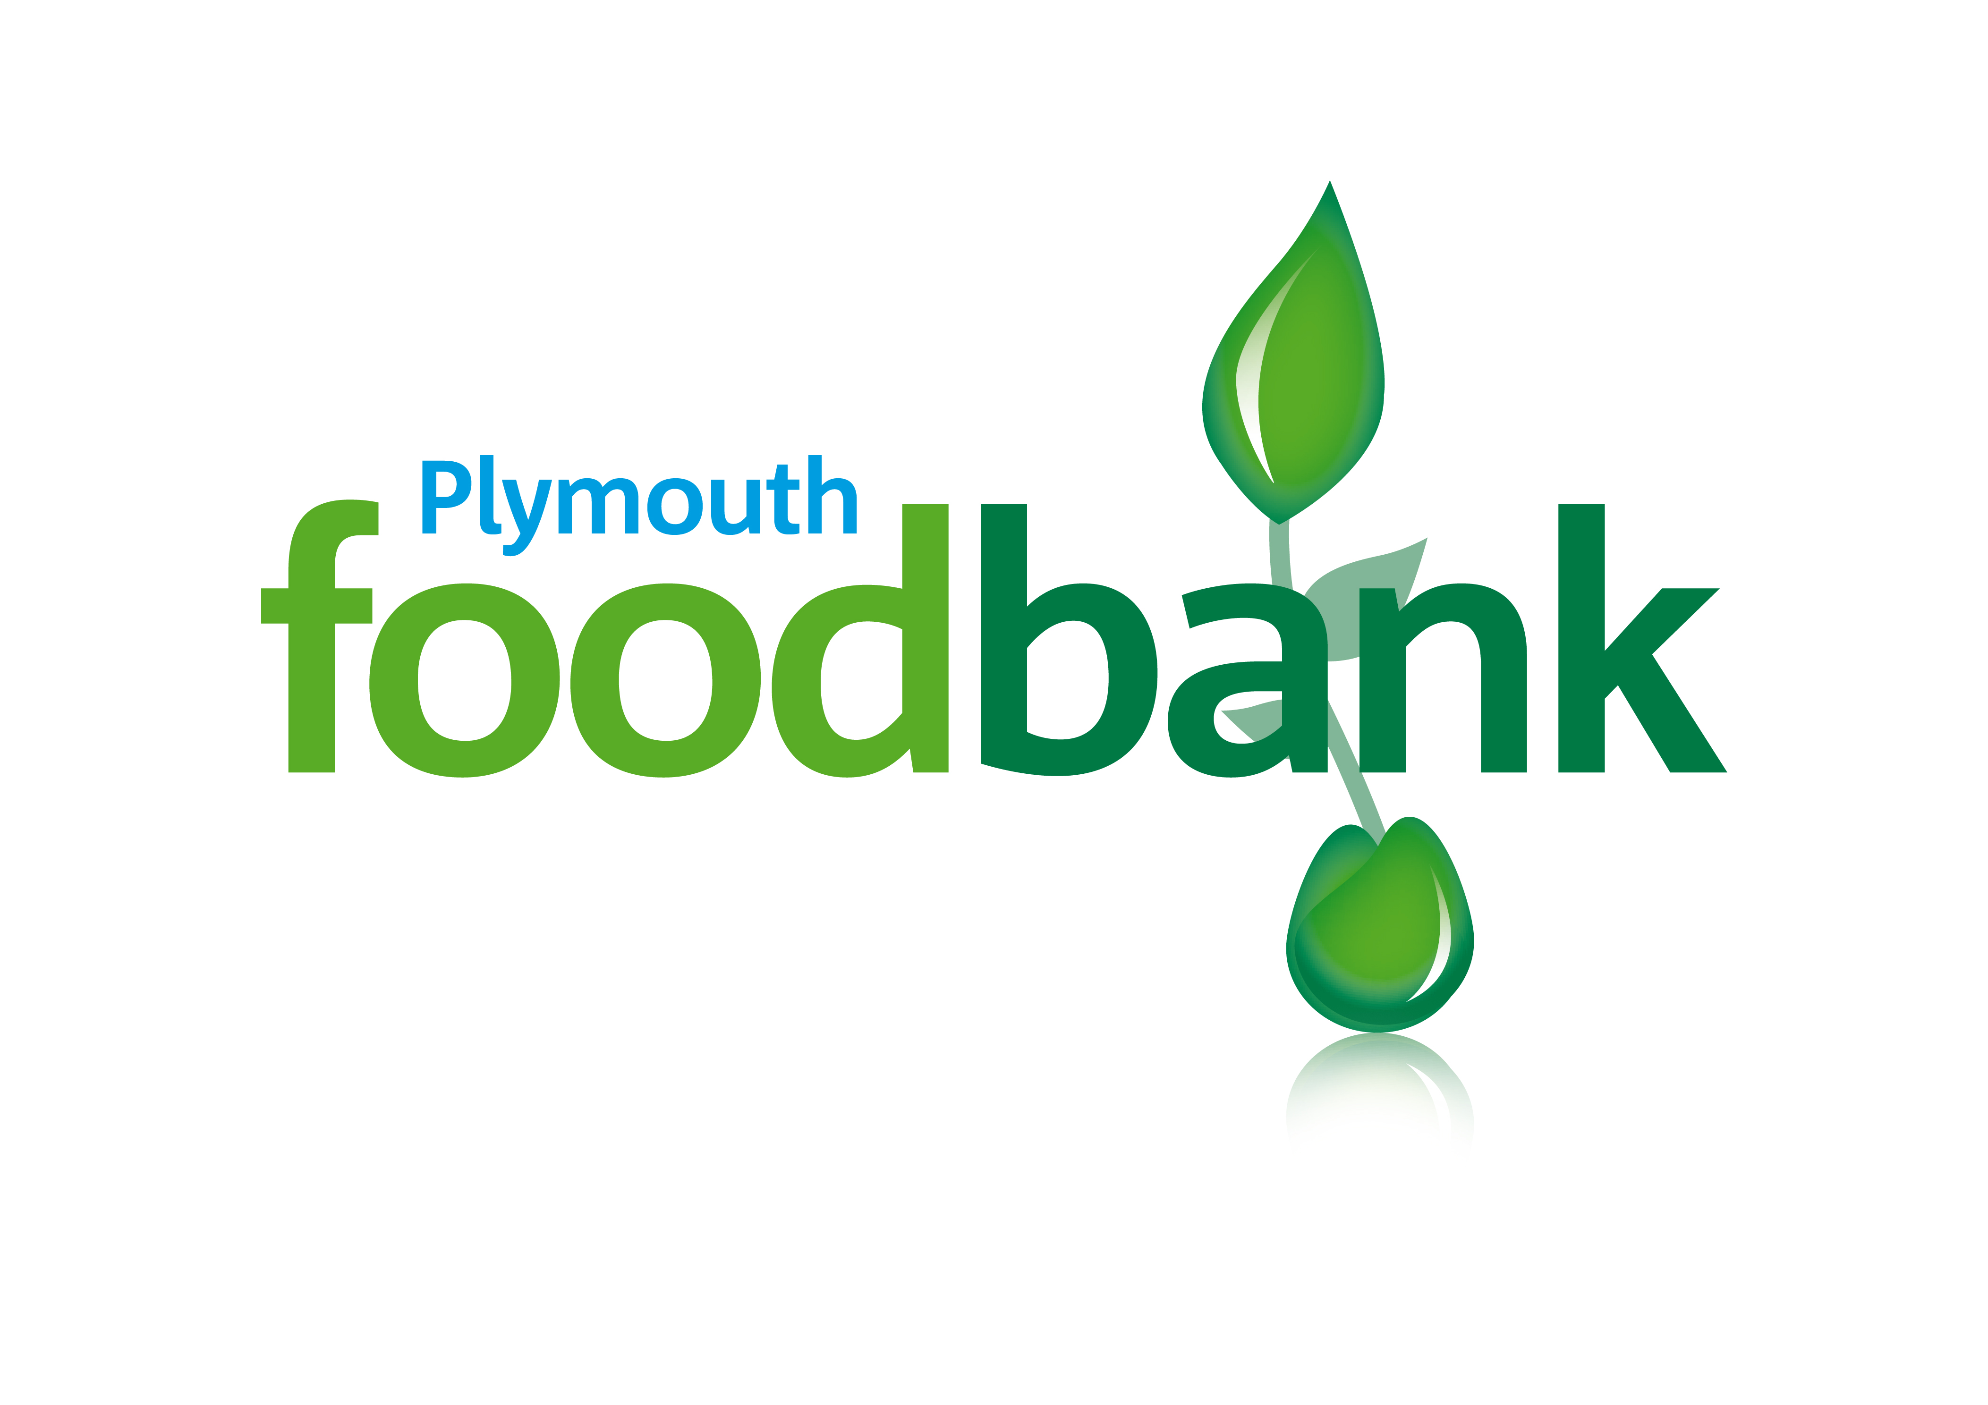

Charity Gift Aid Declaration
Please treat as Gift Aid donations all qualifying gifts of money made (tick ALL relevant boxes)
Today in the past 4 years in the future
I am a UK taxpayer and understand that if I pay less Income tax and/or Capital Gains Tax than the amount of Gift Aid claimed on all my donations in that tax year
it is my responsibility to pay any difference.

Please complete in capitals
Date:
Charity Name: Plymouth Foodbank
Title | Initials |  | Forename |  |  | Surname
Address

 |  |  |  | Postcode
Signature (optional)

Please notify the charity if you:
-want to cancel this declaration
-change your name or address
-no longer pay sufficient tax on your income and/or capital gains
If you pay Income Tax at the higher or additional rate and want to receive the additional tax relief due to you, you must include all your Gift Aid donations on your Self-Assessment tax return or ask HM Revenue and Customs to adjust your tax code.

