Annual Report 2017/2018
We have a fantastic group of volunteers at Stonehouse for Plymouth Foodbank Central and at Estover for Plymouth Foodbank North without whom we could not operate.

We are continually grateful for the time that they give to the project.

North
The Worship Centre
Plymbridge Road
Estover
Plymouth
PL6 7LF
T 07759 258889
E nplymouthfoodbank@gmx.com
W plymouth.foodbank.org.uk

Central and Main Office
The Oasis Project
28 Manor Street
Stonehouse
Plymouth
PL1 1TW
T 01752 254981
E info@plymouth.foodbank.org.uk
W plymouth.foodbank.org.uk

Lots of fun and never a dull moment!
Michael, Volunteer
Very welcoming environment for volunteers and clients. I enjoy contributing to a very worthwhile project, however a shame that anyone needs to come to a Foodbank at all.
Lynne, Volunteer

The Foodbank is about more than food, lack of food in the cupboard
is often about more than hunger

The first time I met Suzie sticks in mind, she arrived at the Foodbank in tears carrying her two month old in her arms, the things she had gone through to get here just overwhelmed her the moment she walked through the door. Once she had composed herself she asked everyone to stop being so nice to her! She later said that she wasn’t used to such kindness and the welcome she received when she entered was not what she was expecting.
A volunteer had noticed straightaway that she was very upset on arrival and moved her to a room so that we could talk. At this point, I did not know if I would be needed to be just a listening ear or use the skills I have to help her to move her situation forward.
I know that each person I meet is in a period of crisis. Helping them by talking about the weather or what they watched on TV last night is absolutely fine, when people arrive at the Foodbank for the first time, they are not always in the right frame of mind to tackle the often complex situation they are in. Being a centre that provides more than food allows me to briefly explain what we can offer those accessing the service when they are ready.
Suzie left with her with her food parcel, nappies and toiletries. She was going back to the temporary accommodation she had been put in, it was a B&B with a shared bathroom and only a kettle in the room. She obviously had been through many experiences and I wondered if I would see her again and be able to use what I know to make things a little easier for her.
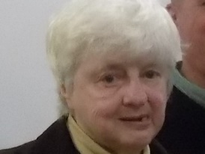
Two weeks later, Suzie presented at the centre once again. This time on her own, she came in with her food voucher and gave it to one of the volunteers who, as always, are there to welcome those in need into the centre. Suzie explained that she had been before and that she was now ready for the help we offered.
I met with her and she explained that she had been married, working full time and pregnant when she had returned from a nightshift to find that her husband had left a note to say that he was leaving her, he had cleared the house and gone. I met with Suzie many times over the period of three months following this first meeting and supported her with claiming benefits, finding accommodation and ways to access what she needed for her baby. I helped her to source counselling and debt support.
Moving forward was something that Suzie wanted to do for herself, she just needed someone there to help her along the way. My role means I can be a scribe, guide and cheerleader all in the same day.
This is what we can do at the centre. Take each person as an individual, give support in the way they need, for the amount of time that is right for them. Suzie is now settled in her own place and is enjoying the time she can spend with her child, before making the move to return to work. I may see her in need of help again one day, I may not, but just knowing that what you have done has had a positive impact on a person is enough. That the process we have for helping those in need is right, from the moment she walked in to a warm welcome, to the moment I closed her file.
Katy Bartlett
Support Worker

Goodbye to Christine
We are sad to lose Christine who died on August 2nd 2018. She helped the Foodbank since we started in 2008, coming in once or twice a week to do the adding and filing as long as she wasn’t visiting some far-flung country or on a Church trip somewhere. Whenever there was training being organised she would be the first to put her name down and regularly attended Regional and national Foodbank meetings. She was a lady of strong opinions who had fought for her independence. We will miss her greatly, the desk upstairs will seem oddly empty on Wednesday afternoons, but we know that Christine is now with her Lord and Saviour, at peace and made whole in Christ.

Volunteer Profile: Di Burrows
About two years ago I started thinking about doing some voluntary work. I happened to go shopping at Tesco and met Katy Bartlett and some volunteers doing a Food bank collection. Katy spoke so enthusiastically about the Oasis Foodbank and I was so impressed by her commitment that I decided to volunteer there. Since starting at the Foodbank I have enjoyed working as part of a dedicated team and helping people who are often experiencing hard times. The Christian ethos of 'help the neighbour' is certainly prevalent there. I am so impressed by the generosity of the people of Plymouth towards their less fortunate fellow citizens.
Since working at the Foodbank I became aware of Plymouth Focus Advice Centre which operates from the Oasis Cafe on Mondays and decided to train as a volunteer with them. They deal mainly with debt and welfare issues and provide help and support often over several years. With credit being so easy to obtain many people find themselves in extremely stressful situations. It is rewarding to work for an organization that can lift the burden of debt and help ease troubled minds. They are an extremely professional organization and do sterling work for the community.

Students
Most weeks through term-time we have students at the centre and nearly always they say the foodbank wasn’t like they expected it to be and they now have a different view of the problems facing many people in Plymouth. They are medical students, social work students, nurses, health visitors and foreign students with TELLUS and Mayflower College.
“I feel the whole afternoon was a great experience for me helping so many vulnerable people and seeing your team do
a great job.” Melissa

Project Co-ordinator Report
As always it has been a busy year. We have received 1588 donations of food and been able to provide 8475 parcels of 3 days worth of food. This is slightly down on the previous 12 months despite Universal Credit being rolled out in the City during this year. We have latterly noticed an increase in people having less money due to recoupment of crisis loans 10 or more years old. In addition to the support offered by the Npower vouchers we have held budgeting meetings with people needing help with their fuel costs as well as referring them to their fuel provider for credit.
Eunice Halliday OBE

We started the year in working towards and gaining the MATRIX accreditation for our information advice and guidance as we have always been more than food. We then spent several months making sure all our processes and documentation here at Central and at North comply with GDPR. We have participated in meetings about Food Poverty with Food Plymouth, a Child Poverty Awareness event facilitated by Price Waterhouse Cooper also taken part in research about Universal Credit and foodbanks. Plymouth is one of 12 centres in the country asked to comment on issues being discussed at the DWP Operational Stakeholder Engagement Forum.

Challenges

As always we want to get the right balance between support and the danger of allowing people to become dependant on the service.
To have enough food of each type to make the parcels nutritionally correct.
A BIG thank you to all our donors of food and money and to those who help in other ways such as Larry Speare gives us parking space, St Pancras Church gives us storage space.
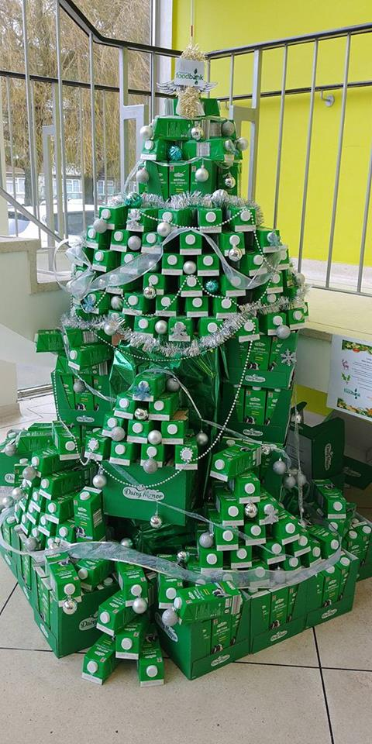

Millfields Inspired helped inspire us this year by making and donating a Christmas Tree made completely of longlife milk!

At Plymouth Foodbank we have two distribution centres, central in Stonehouse and north in Estover. Here is a snapshot of what has happened in the north centre this year.

We can once again praise God for His provision throughout the year. There have been times during the year when our stocks have been somewhat depleted but thanks to the support we have from local churches, schools, voluntary organisations and businesses we have never run out and nobody has gone away without a full parcel of food. On one occasion we were down to our last tin of tomatoes. A gentleman came in from one of our supporting organisations with a contribution and asked what we were short of which was tomatoes and within 20 minutes he had returned with a whole tray of them. You may think that is coincidence but we believe God provided for us. This has meant that we have not had to make too many purchases throughout the year.
A big thank you to all those who have supported us with donations throughout the year.
The number of people we have seen in the Foodbank has again increased, particularly since the roll out of Universal Credit last October. The stock in and out as at August 2018 has shown an increase of almost 2,000 kg both in and out leaving our stock almost the same as this time last year indicating what came in went out.
Katy from Plymouth Foodbank – Central continues to be on hand with us once a month and this has proved really useful in being able to offer her services to clients in need of help and support particularly with benefit issues.
We have maintained close links with Churches and Schools in the area who donate much of our stock. The links with the schools have been maintained and have seen us attend assemblies throughout the year particularly at Christmas, Easter and Harvest. Also we have forged close links with the Parent Support Advisers at four schools in the area which means we have been able to support parents in need particularly during the school holidays. We would hope to continue with this and maybe bring more schools on board in the future.
With regard to the building, we had a problem with water ingress during the winter months. Largely due to the fact that the prevailing wind drives rain directly at the door of the portacabin and the fact that the rain was exceptionally heavy. We have now had a porch put on the building which has solved this problem and also should make the place warmer to work in during the winter months as the weather will not be driving straight in the door.
We look forward to continuing to serve the Community in the coming year.

