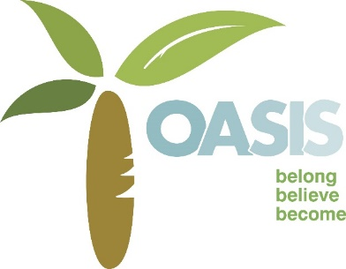
28 Manor Street, Stonehouse, Plymouth PL1 1TW.
www.oasisproject.co.uk
A project of the Methodist Mission Circuit Charity no. 1129521
Annual Report 2017/2018
Training: We have run our adult education courses with our tutors Judith (Art) Robert (Maths) Keith (English) Phil, Derek and Arthur (IT) Will and Hayley (Job club) Maria (Cookery and Food Safety). We have had students take examinations in Maths, English and Food Safety with excellent results, but more importantly we have been able to see them grow in confidence and skills. We have taken a lot of time to follow up on current and previous students and overwhelmingly they report increased confidence and wellbeing. All of them have benefitted from expanding their horizons. Sadly, this year we lost one of our long term students Nicholas who had just completed his level one English qualification, but following a suggestion from Keith we are creating the Nick Holmes Award for the most improved student.
One of our students who came to cookery lessons suffered with Asperger’s Syndrome and rarely left the house. On the first session he locked himself in the toilet and had to be persuaded to come out. He did complete the six week course and decided that he really enjoyed cookery, he went on to get a job working in a local café as a kitchen porter, a job which he held down for twelve months until the café ceased to trade.
Our job club runs with the help of Plymouth Community Homes worker Hayley Kemp and Will Notley a volunteer, and we were very pleased to receive from PCH £1000 worth of equipment such as filing cabinets, memory sticks and office furniture which helped us to improve the service we give and meet our GDPR requirements. People have come in and updated their CV and Hayley and Will have helped many to migrate to the new job search site which went live in May. Sharon says that “They are wonderful, so patient and they know their stuff”. Praise indeed. Sixteen people have gained work following contact with the Oasis Project.
RB who comes to our English classes came in proudly in March to tell us that he had written his Christmas cards out for the first time ever! He wanted to make sure he got them right so gave himself plenty of time.
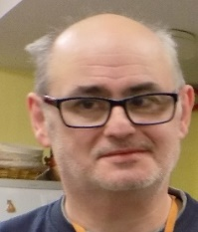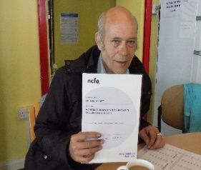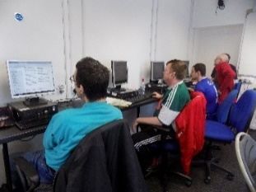
Nick Holmes Richard Barnett Computer lessons
Eunice went to London to the House of Lords with Mark one of our Learn My Way students to talk about the impact that becoming computer literate can have on people’s lives. The opportunity for Mark to be able to talk to the peers of the land and for his contribution to be valued was a wonderful experience. We have obtained funding from the Good Things Foundation to support 67 people with disabilities as we continue to offer the computer course three times a week and the support offered is high quality with many people achieving certification of course completion. From this year’s students who responded to our survey 41 (67%)have gained qualifications, 16 (22%) gained employment, and 29 (67.2%) stated that their self-esteem had gone up as a direct result of their courses, 9 (14.7%) have gone on to volunteering roles. Also 43 gained food safety qualifications. Of the 114 students this year we got responses from 61 which is 53.5% of the total.
MG just took her first English examination, she says “It is a very interactive course and great support from the tutors. Lots of homework to keep abreast of the next weekly session. Very good tutors, nice atmosphere, friendly and professional staff.”
JM comes in once a week to learn to read, which at the age of 85 is incredible, this is what he says;
“I am very grateful for all you have done for me since I have been coming here. I am still not reading as I would like to be able to that is why I would like to keep coming here as long as you will let me carry on. When I went to college I hardly learnt anything, the numbers there are the thing that they are concerned about, I need the quiet here. I will give 100% back to you for the time you give to me. Thank you.”
The art groups run on Tuesday and Thursday, and have been so successful that Judith had a waiting list for Tuesday. The group have created some wonderful pictures which can be seen in the windows, but also made peg bags, pin cushions and stuffed toys. For some the thought of using the sewing machine was awful, now they queue up to get their work completed. The group are really supportive of one another and have gelled together well, there is a lot of laughter that can be heard on these days, Tuesday is anything but a quiet morning in the centre!
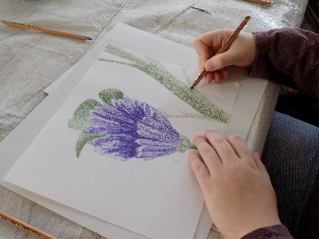
Community Engagement: We have had the opportunity to be involved in events in Victoria Park, at Christmas we did a ‘scratch’ Nativity, one of the mums said that she had not sung Christmas carols for a long time and that this had really made the time special. In the summer Eunice and Judith encouraged people to work with clay and art materials in Victoria Park the sun shone and many clay animals were created. We hosted an art exhibition for the 100 Homes Project, some of the pictures are still in the centre, including one of the centre when it was the Crown Hotel from the 1930’s. We have provided food for the Union Street Fun day and were there rain notwithstanding! We have hosted two Bishops for tea, and Ridgeway Ladies group for a very genteel afternoon tea. We have also been into St George’s School with our Open the Book assemblies and had seven Open the Book Holiday clubs in the centre. We have run the Puzzling Questions course again which encourages people to look at six big questions of life; Who am I? What is God like? What happens after I die? How can I be happy? Why is there suffering in the world? What is the spiritual world, and how does it impact on my life? One of our social work students continued to attend even after her placement had finished so that she could complete the course. Our group of local mums who regularly attend our Open the Book holiday club also attended the Light Party and Messy Church Christmas party at Methodist Central Hall. We have had picnics on the Hoe where we flew kites and talked about Pentecost, and we had fun in Devonport Park, playing rounders and croquet. The mums all said that although they lived locally they did not use the local parks. Since then they have regular trips to the Hoe to enjoy the glorious weather we have had this year. We enjoyed a trip to Paignton Zoo and the Living Coasts, with picnic, travel and entrance fees paid for, we were grateful to the Drake Foundation for a grant towards the costs of these trips, for some of the children who access our services it is the only time they get to go away during the summer holiday.
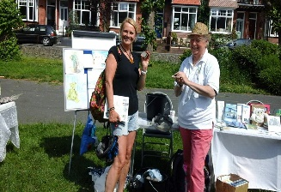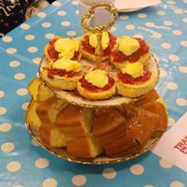
Judith and Liz at the park cream tea.
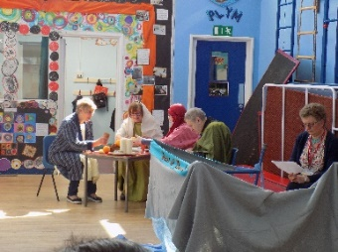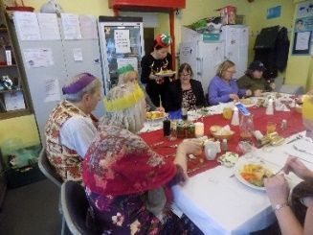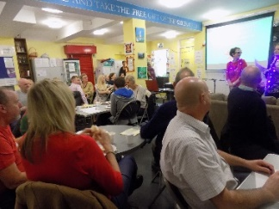
Open the Book at St George’s School 2017 Christmas meal. Christmas Quiz for Volunteers and staff.

Project Development: We were awarded the Matrix Accreditation for Information Advice and Guidance (IAG) this year which recognises the work we do with both centre users and our volunteers and staff, this meant looking at all of our policies and procedures to ensure that they were ‘fit for purpose’ and that the advice and guidance we give is to a professional standard. It is great to have a nationally recognised accreditation and it helps us to show to other organisations and funders that we work in a way which values all people.

The changes to the General Data Protection Regulations (GDPR) involved us looking at every piece of paper we store, all the information we hold and how we communicate with people and how people are informed of our processes. This varied dependent on whether they are students, centre users, Foodbank users or our volunteers, we are pleased to say that we were ready for the May 24th cut-off date with a big thankyou to Katy and Eunice for all their hard work.

Catering: This has been a challenging year for the café, with only three outside contracts we have struggled to meet the costs involved in running the café. We did have a successful Christmas Lunch where 32 people came and had a full three course meal with drinks for £12.50. We hosted an afternoon tea for two Bishops, and afternoon tea for a ladies group. However, the down turn in the demand has meant that we have been forced to lose Angela as our cook and change the offer to that of sandwiches, tea cakes and drinks. We will miss Angela but her legacy of fantastic cakes will continue.
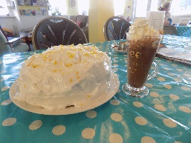

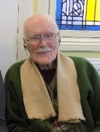
People: This year we lost our oldest centre user, Stanley Mullans who died aged 101, we were privileged to attend his funeral complete with military honours, Stanley was a Burma Star holder.

Stanley Mullans

We have currently seventy-nine volunteers working either with Oasis or the Plymouth Foodbank, all of which have to go through safer recruiting, on-going follow up and support, we have also been host to students from Tellus and Mayflower organisations, they have come Germany, Italy, Switzerland, Romania, France and Poland. It has been a great joy to see them come in so quiet and shy and leave feeling that they are part of ‘the family’. We have had medical students who arrived in pairs, and two first year social work students, all of whom have benefitted from the variety of roles and the ethos of the centre. We would like to thank our Trustees and management committee for their support, and Reverend Dave Martin who has chaired our committee for seven years and who is now retiring, we wish him and his wife Jane a long and happy retirement.
Our pastoral care of both centre users and volunteers continues to be a big part of the work of the project. We have assisted volunteers and centre users through issues such as health, benefits problems, depression, self-harming, and self-esteem problems. We have been able to celebrate with people when they have gained work or volunteering opportunities, been alongside as exams were taken and goals reached. We have mourned the loss of some wonderful centre users and friends. We have prayed with friends, explored God’s word together and served the community in His name.
At this point I thought that I had finished the annual report, but Christine Fitze as usual had to have the last word! Christine died on August 2nd having been our longest serving volunteer, starting with us in 1996. She did a number of roles, she helped with Time Out children’s club, collected at supermarkets, was on the Oasis Committee and latterly kept our Foodbank filing in perfect order, defying me to let anyone else touch it! Everyone who knew Christine described her as ‘a character or tenacious, strong willed, loyal, a kind person and a firm and faithful Christian. Christine did more training courses than any other volunteer at the centre and her journey of learning never finished for her, one of her proudest moments was graduating from the Open University. She was keen to represent the centre at various conferences and could be relied upon to tell you if she did not agree with something. We will miss her greatly, the desk upstairs will seem oddly empty on Wednesday afternoons, but we know that Christine is now with her Lord and Saviour, at peace and made whole in Christ.
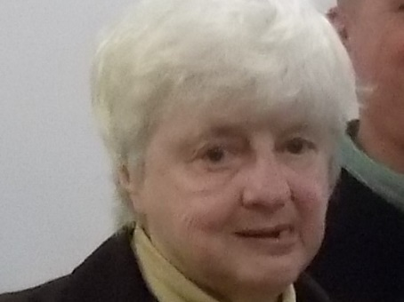 Christine Fitze

We continue to grow and change in response to the needs of the community and God’s leading, we hope that you will be happy to be a part of our journey, that together we will continue to be an Oasis of hope and healing serving the people of Plymouth where we are planted.
We exist due to the invaluable support of local donors and these organisations, we thank you all.

Garfield Weston Foundation. Virginia House Settlement

